**European Cognizance of the Lake Memphremagog Region**

At what point did Europeans, or their colonial descendents, first become aware of the existence of the relatively large body of water we now call *Lake Memphremagog*? Moreover, when did European eyes first behold its shores? These are not questions to which precise answers are possible, but the surviving documentary evidence at least constrains our speculations as to when and why, if not who.

The quest for a shortcut to the orient, and the expansion of the fur trade, were the two primary drivers for French exploration in the 1600’s[1]. The former pushed the French west, and ultimately south, along major waterways and long-established native trade routes[2], but never in the direction of the Atlantic seaboard. On the other hand the fur trade required a rich beaver territory inhabited by a significant population of native trappers. The area of the Eastern Townships in the 1600’s was a moderately poor beaver habitat, but more importantly, it was apparently devoid of any significant and permanent First Nations presence[3]. Thus there was little incentive for the French to explore the St. Francis watershed, and if contact was desired (and it wasn’t) with the Dutch along the Hudson, or the fledgling English colonies along the Atlantic seaboard, then the route up the Richelieu to Lake Champlain, and then down into the Hudson Valley was infinitely more navigable. The St. Francis River watershed remained *terra incognita* for Europeans, and only gradually came into focus as the result of conflict.

In the period 1648 to 1653, Mohawk (Kanienʼkehá꞉ka) war parties raided to the east and attacked Sokokis and Cowasuk settlements along the middle and upper reaches, respectively, of the Connecticut River valley. They took prisoners and likely dispersed much of the population. In 1663 and 1669 these attacks resumed, and this time a large number of Cowasuck and Sokokis sought refuge closer to the French (although the French themselves were under siege by the Iroquois). In 1663 some of the Sokokis settled temporarily near the mouth of the St. Francis River (the first settlement of what became Odanak)[4]. In their short occupation at Odanak, their exchanges with the French were probably infrequent. The post at Trois Rivières was the closest French establishment, some 60 km down river. Perhaps they may have disclosed to the French, to the degree language barriers permitted, the rudiments of the St-Francis- Lake Memphremagog – Black- Nulhigan– Connecticut route. However knowledge and control of canoe-portage routes was quite strategic, so it is equally probable that this information was not shared, or even inquired about. As the Iroquois menace subsided the Sokokis returned to their traditional territory.

A refugee village at (or near) Odanak was again established in 1676, as Abenakis fled the depredations of both the Mohawk and the English at the end of the hostilities known as King Phillips War. Appreciable numbers of Abenakis fled to the St. Lawrence valley in the period 1673 to 1677, alliances were forged, and it seems reasonable to assume that the French would have become aware of the St. Francis River corridor during this time. Whether specific knowledge of Lake Memphremagog also emerged, is speculative.

In the winter of 1690, in retaliation for the *Lachine Massacre* that previous summer (August 5 1689), Governor Frontenac sent out 3 mixed Indian-French expeditions against New England and New York settlements. The expedition that commenced from Trois Rivières, led by Francois Hertel, and composed of 25 French militia and 22 warriors from the village of Odanak (St. Francis), is postulated to have used the Lake Memphremagog route (see Eccles,1964). With snowshoes and supplies carried in Indian toboggans, the 40 km frozen surface of the Lake was an easier and faster path than any trails through the woods clogged with snow. This may well have been the first time European eyes saw the lake, albeit in its winter’s garb.

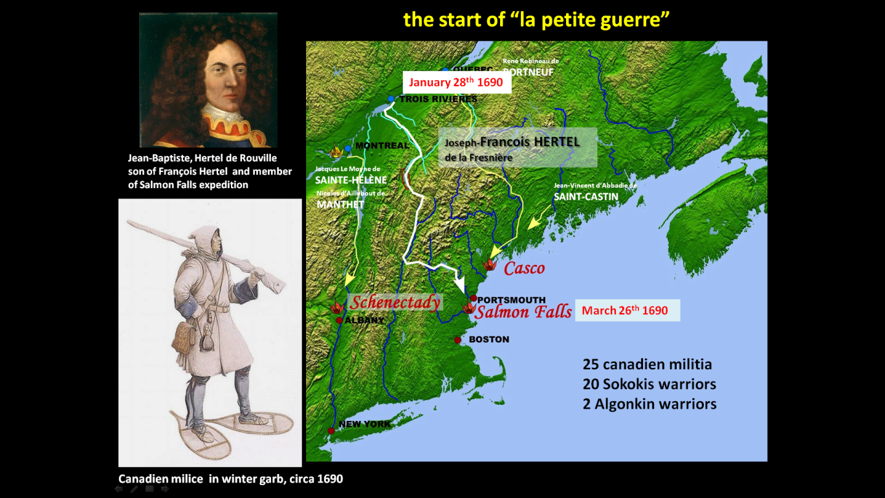An excellent account of the raid can be found in Chartrand (2019).

***Postulated route taken by Joseph-Francois Hertel de la Fresnière and 46 others to surprise attack Salmon Falls on March 26th, 1690. Location of Lake Memphremagog indicated by red oval.***

***This route, well known to the Sokokis warriors, may have permitted Europeans to see Lake Memphremagog for the first time.***

Odanak was established permanently in the year 1700, as a mission village[5].

Father Joseph Aubry (also spelled Aubery in some documents) was the Jesuit missionary at Odanak from 1709 to his death at that place in 1756. It would have been wonderful to have had a conversation with Father Aubry towards the end of his life, for he travelled extensively in the Abenakis homeland, and almost certainly visited Lake Memphremagog on a number of occasions. Like all Jesuits of that period, he was well educated, and certainly had the rudiments of the various scientific and technical fields, as they were understood in his day. In 1713 his cartographic and geographic skills were required. In that year the French were negotiating with the English the termination of Queen Anne’s War (War of the Spanish Succession). The French had lost this particular round, and were being forced to relinquish all claims to Acadia to the British, with the exception of Cape Breton Island. But what was Acadia, and what were its bounds? Either at the request of the métropole, or perhaps on his own volition on behalf of his Abenakis flock and their kin, Aubry constructed a manuscript map of Canada, largely from second hand information from the Abenakis themselves. The map was intended to inform the French government, and presumably guide the French negotiators. In the end, the Treaty of Utrecht, which brought hostilities to an end, left the definition of Acadia quite vague and open to interpretation. The Aubry map however is fascinating as it is the very first map that shows Lake Memphremagog. On the map it is labelled Lac Memeraoubeghé, and as Aubry was fluent in their language, we can be assured that the French phonetic spelling, is a reasonable reflection of what the Abenakis actually called the Lake.

No French maps[6] drawn later on in the 18th century offer a more accurate rendition of Lake Memphremagog than the one constructed by Aubry. Does this mean that geographic knowledge remained stagnant? We do know that two individuals, Noël Langlois dit Traversy, and Pierre Abraham dit Desmarets, were sent into the upper St Francis region in 1742 on the orders of Intendant Hoquart, in search of suitable mast timbers for the French Navy. Surely they would have produced some crude sketch maps of their explorations? But did they proceed up the Magog River as far as Lake Memphremagog? The results of their investigations have not been preserved.

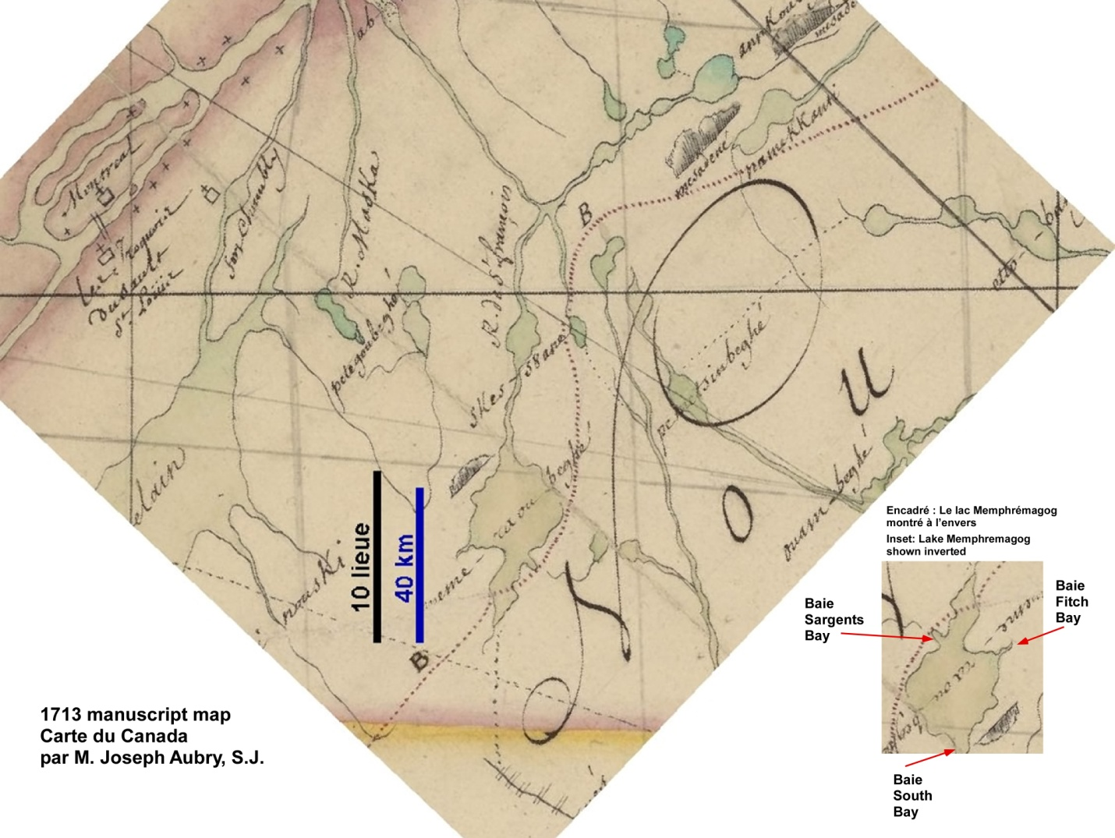

***Portion of 1713 Aubry manuscript map showing Lake Memphremagog (Memeraoubeghé). The length of the Lake is surprisingly accurate, but its shape suggests that Aubry may have drawn it from 2nd hand information, rather than personal knowledge. True it is elongate in a north-south direction, but where it is narrow and where it is wider, seems to have been reversed on the map. If the image is inverted it makes a great deal more sense (see inset). Could Aubry have based his depiction on an indigenous sketch of the Lake, where the expected conventions of orientation were not employed? The mountainous side of the Lake is shown correctly however. Lake Magog is also shown. For indigenous persons, it was the connections the waterways made, not their shapes, that truly mattered. The purple dashed line is a crude approximation of the height of land, separating watersheds that flow into the St Lawrence, from those that flow to the Atlantic. Most of the black dashed lines represent land routes and portages.***

The *preserved* documented geography of the Lake did not improve for another 43 years.

In 1756 a manuscript map of New Hampshire province was published by Samuel Langdon, and north of the Great Cohasse (Coos) of the Connecticut River, most of this map was based on the testimony of John Stark, who in April of 1752 had been captured by the Abenakis, and had been brought back to Odanak (known more commonly by the English and French as St. Francis) via the Lake Memphremagog route. After a little over a year Stark was eventually ransomed, and he returned with first-hand knowledge of the St Francis River watershed.

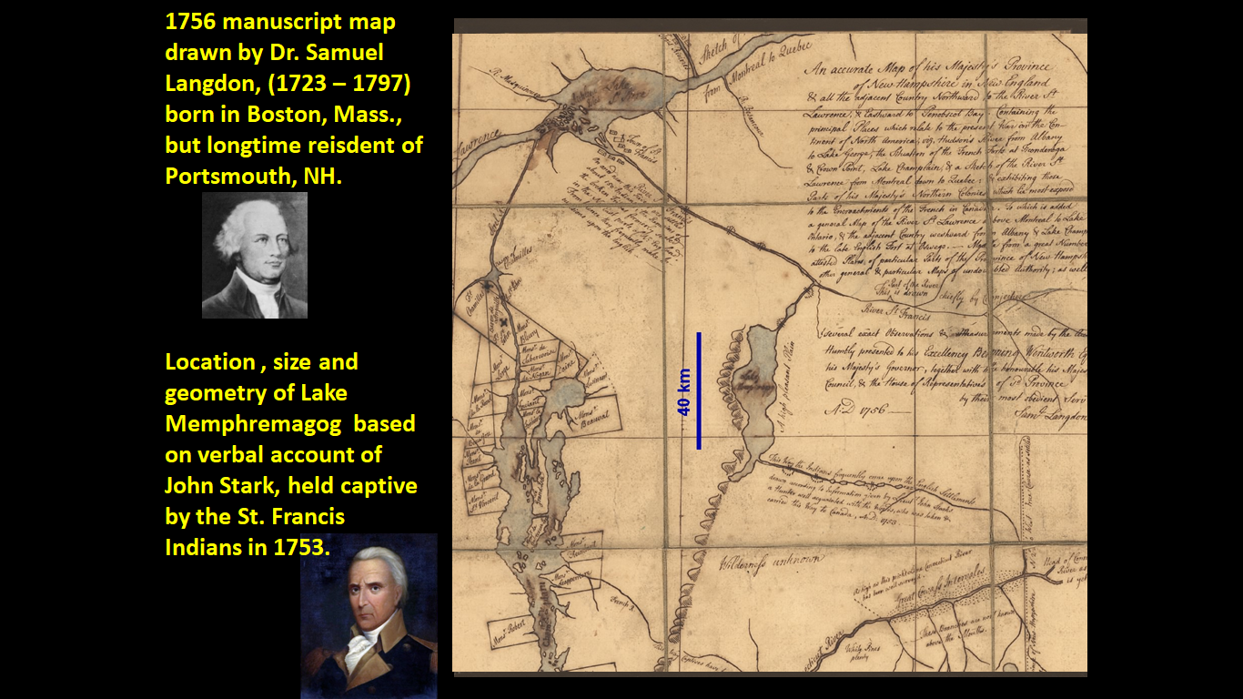

***Portion of 1756 manuscript map by Dr. Samuel Langdon, resident of Portsmouth, New Hampshire. Lake Memphremagog is based on oral testimony of John Stark, who had been held captive as a very young man by the Abenakis in the region for nearly a year before being ransomed. Stark would go on to become a member of Rogers Rangers (but he refused to participate in the raid on St. Francis – see below - out of allegiance to his adoptive Abenakis parents), and later he was an American general in the Revolutionary War (and hero of the Battle of Bennington). South Bay and the Clyde River are prominently shown, the Lake is appropriately scaled and elongated in a north-south direction, widens in the middle and is narrower at its north end. All are depictions missing on earlier maps. Apart from South Bay (which deflects in the wrong direction), no other bays are shown.***

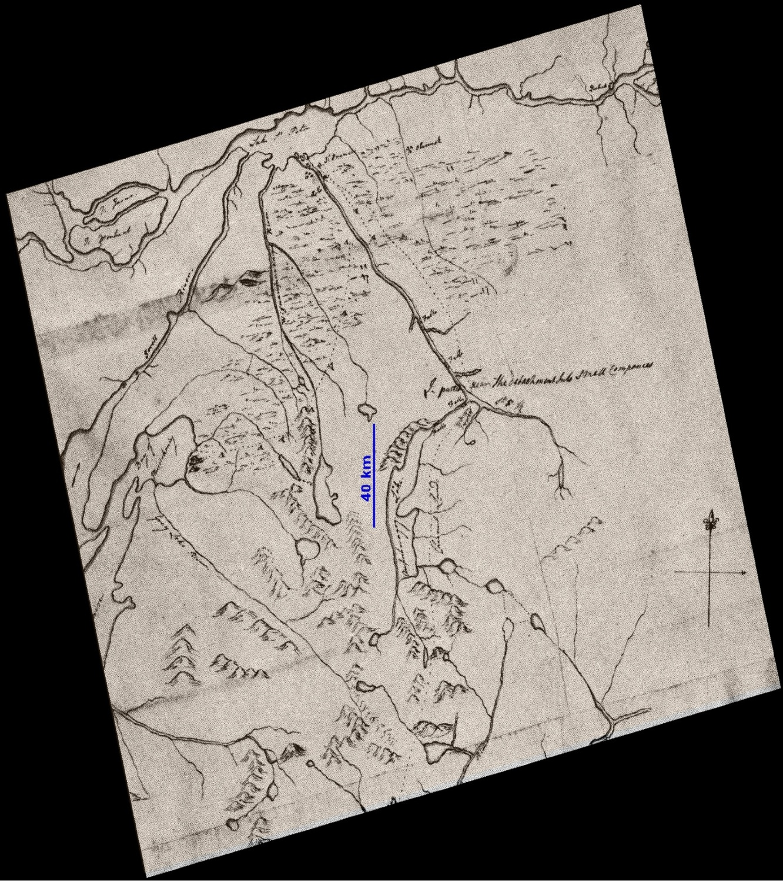In mid September of 1759, the British general, Jeffrey Amherst, launched a “punitive” raid against the Abenakis village of St. Francis (Odanak). Ironically the raid was launched the very day (September 13th) Quebec fell to General Wolfe. From Crown Point on Lake Champlain, Major Robert Rogers and 8 companies of his rangers and provincials (totalling 200 men), first by whaleboats then by an arduous 12-day trek overland, approached the village of St. Francis unnoticed on the evening of October 3rd. They attacked very early the next morning. The surprise was complete. Many of the Odanak warriors were gone from the village, and so Rogers men were largely attacking a village of women and children and younger braves asleep in their cabins. Estimates vary widely (Rogers greatly exaggerated the numbers to 200, the French minimized them to 20), but the bulk of the evidence would suggest that between 55 and 65 villagers were killed. The village was razed to the ground. This was not a battle, it was an act of genocide.

***Facsimile of a portion of Robert Rogers map of his expedition to St. Francis (Odanak) in September 1759. Lake Memphremagog is labelled “Amprahmagog Lake”. Note the annotation “Pleasant Lands” just to the east of the Lake. Word would spread amongst New Englanders of the region’s desirability.***

Their path of retreat was cut off, and so Rogers ordered his men, in smaller groups, to attempt various routes through the wilderness to reach safety. It is an epic tale, immortalized by Kenneth Roberts in his novel “Northwest Passage”. Of the 142 men that made it to St. Francis, only 73 made it out alive. One of the groups, led by Rogers himself took the route past Lake Memphremagog, and Rogers was requested to sketch a map of their group’s path of retreat for the benefit of General Amherst.

In Roger’s sketch, the Lake is starting to take on a recognizable form. It is narrow and elongated in a north-south fashion, it is approximately the right length, and clearly shows indications of both Sargent’s and Fitch Bay.

Once the Treaty of Paris had been signed in 1763, this un-ceded hunting and fishing territory of the St. Francis tribe in the vicinity of Lake Memphremagog, was undoubtedly traversed by numerous outsiders. We are told by Pierre de Sales Laterrière (1743-1815), who travelled up the St. Francis en route to Boston in 1786 with his brother-in-law and a guide, that when they reached Grandes Fourches (present-day Sherbrooke), that the names of previous travelers were seen to be inscribed or painted on rocks or squared posts, and that these names were “*très nombreux*”. These early travellers would have ranged from traders to trappers to land speculators. Few left any record of their travels, so we are fortunate to have the memoir of Laterrière (published posthumously in 1873) in which we have the earliest preserved description of Lake Memphremagog, which he describes as “*grand et vaste*”, and as having an overall funnel shape. In particular he describes two large islands on the Lake, including l’Ile des Noyers (probably Molson Island), and the island cut by the boundary line (Province Island), run in 1772 (see following).

In 1771, on behalf of the New York and Quebec governments[7], a joint survey party was sent to delineate on the ground the boundary between the two provinces, which was to correspond to the 45th Line of Latitude. The survey was to proceed, starting from a fixed point of latitude on the Richelieu River. From this location the survey would first go to the east and the headwaters of the Connecticut River. Subsequently (1773-74) it would proceed to the west and the St. Lawrence River. Slogging through the uncharted wilderness, the survey took 4 years. By July 24th of 1772, the survey team had reached the eastern shore of Lake Memphremagog. Amongst the surveyors were Americans heavily involved in land speculation, and because of the reports of Stark, Rogers, and perhaps others, the Lake Memphremagog region was thought to be prime real estate for would-be settlers. Although it was not part of their mandate, the survey team took two weeks off of the 45th parallel work, to map Lake Memphremagog. Their mapping efforts were then passed on to accomplices in Quebec City who, within a month of the survey team returning to that city, were petitioning the government for huge swaths of land. Their petitions were accompanied by quite extraordinarily detailed and accurate maps of the Lake! The petitioners were denied.

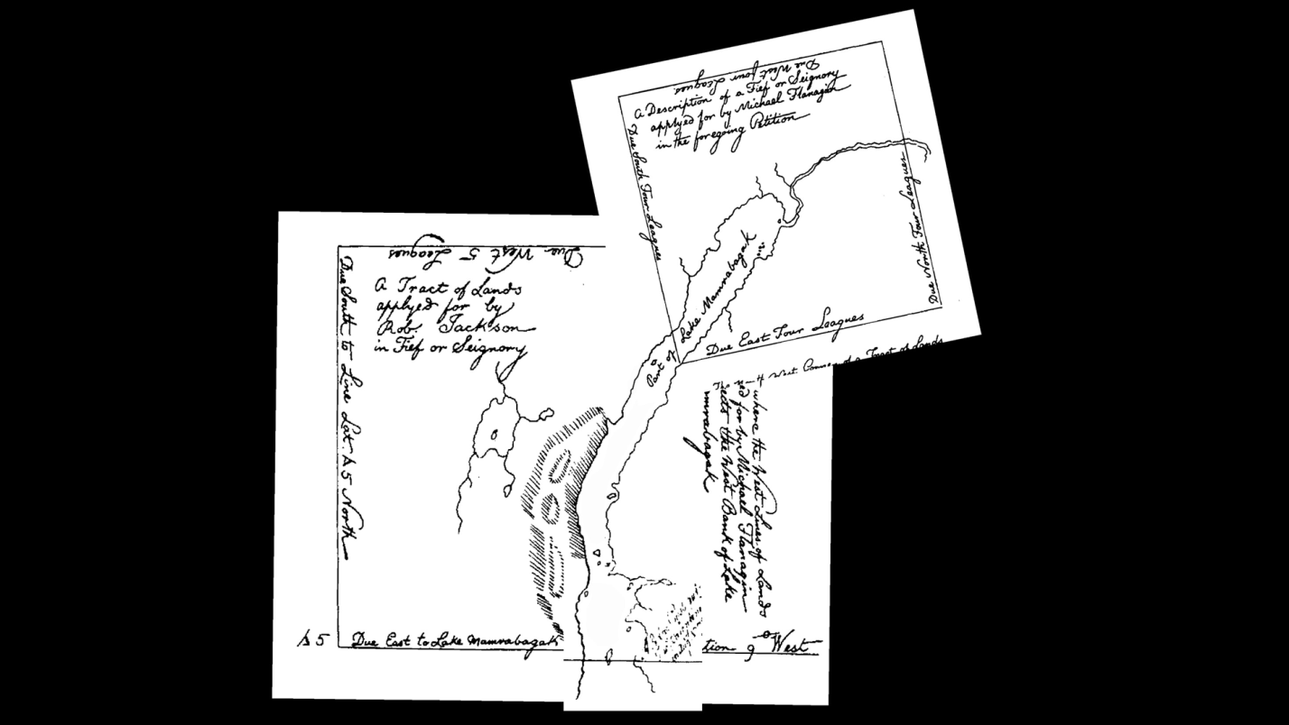

***A composite of the petition maps seeking a huge swath of lands (>300,000 acres) surrounding Lake Memphremagog. These maps were drawn from “side” work done by the 45th Line of Latitude Boundary survey. The survey team returned to Quebec City at the very end of October, 1772. By November 14th, the first of 3 separate (but coordinated) petitions had been received by the government. The petitioners were denied.***

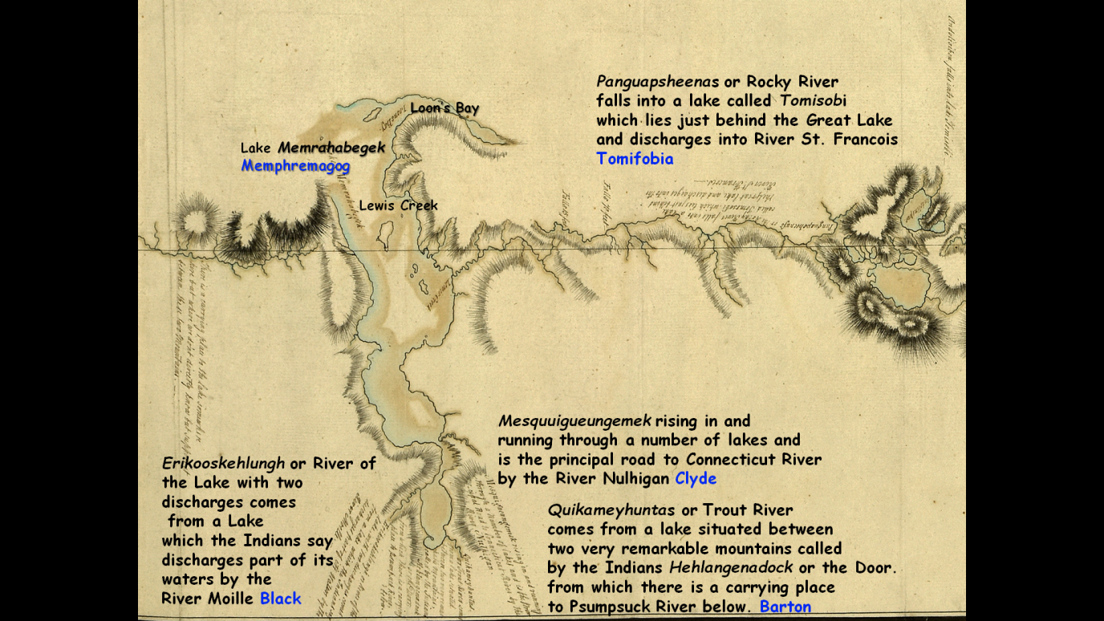

***The official map produced from the survey did not include the entirety of the Lake. Drawn by John Collins, Deputy Surveyor-General of Quebec and completed sometime between the end of the survey (October 1st, 1772), and being enclosed in a letter to the government in England (October 1st, 1773).***

The survey of the boundary, was viewed with suspicion and hostility by the local Abenakis dwelling in their seasonal camps on the Lake. The carving of a dead-straight path by white men through the wilderness, up mountains, down mountains, a path that came from nowhere, and ended up nowhere, must have been seen as ludicrous by the Abenakis, but they most certainly also saw it as a portent of the eventual loss of their territory and their sovereignty. When the surveyors erected a large post on the east shore of Lake Memphremagog, the Abenakis promptly pulled it down.

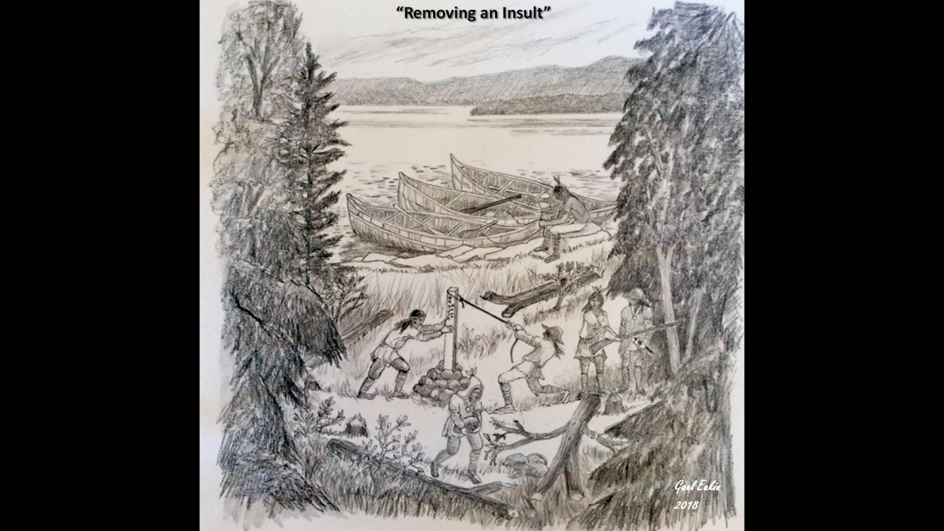

***Sketch by Gael Eakin depicting Abenakis pulling down the marker post on the east side of Lake Memphremagog View is towards the west with Province Island and Bear Mountain in the background.***

**References**

Chartrand, R. 2019 Raiders from New France: North American Forest Warfare Tactics, 17th – 18th Centuries. Osprey Publishing Ltd. 64pp.

Eccles, W.J. 1964 Canada Under Louis XIV 1663-1701, Vol III of Canada Centenary Series

Laterrière, Pierre de Sales 1873 Mémoires de Pierre de Sales Laterrière et de ses Traverses.

L'imprimerie de l’evenement, 271 pp.

1. There were other drivers. For instance, the need for better communication between far-flung outposts, diplomacy with First Nations, and exploration for exploration’s sake, would represent other incentives. Undoubtedly the latter two were responsible for first-hand experience of the French with the Chaudière River route to the homeland of the eastern abenakis bands, accomplished by an emissary of Champlain’s in 1629.
2. i.e. exploration of Great Lakes region, headwaters of the Missouri River, and Mississippi by such explorers as: Radisson and Grosseiliers (1659-1660), Jolliet and Marquette (1673-74), and LaSalle (1682-83).
3. The Abenakis of the 17th century referred to the St. Francis river as *Alsigontekw*: “the river where there was no one”. There may have been a much more significant native occupation of these territories in the 1500’s, and most certainly we know from the archaeological record there was permanent habitation in the watershed region in the pre-contact era.
4. As early as 1658 a Sokokis was baptized in Trois Rivières, suggesting some of the tribe had migrated to this area by that date.
5. While traveling along the banks of the St François river the Jesuit Priest Jacques Bigot made the decision to relocate the Jesuit mission “La Mission de Saint François de Sale” that was established in 1684 at the mouth of the Chaudière river, to the banks of the St Francois river following years of successive crop failure due to agricultural over exploitation. The new mission was to be established in close proximity to a small village of both Abenaki and Sokokis that Bigot had previously observed during his travels throughout the region in the winter of 1684-1685. At the request of the Governor General of New France Louis-Hector de Callière and the Intendant Jean Bochart de Champigny , Marguerite Hertel the widow of Jean Crevier and her son Joesph Crevier granted one “demi lieu” of land from their seigneury to the Abenakis which was accepted on behalf of Bigot on which the new mission was to be constructed. In 1704 the French King Louis XIV ordered the Kings Engineer, Levasseur De Néré to draw up a plan in order to fortify the Jesuit Mission during the War of Spanish Succession, to provide protection for the families of the Abenaki and Sokoki warriors who had sided with the French against the British and the Iroquois during the war and in prior conflicts. Governor Callière subsequently ordered the construction of defensive features such as redoubts and a 4.7 m high palisade that was to be reinforced with stone bastions. Since 2010, archaeological investigations at Odanak have located the remains of this fort.
6. That are known to exist
7. At that time, both were royal provinces.